Edge Vision: Bank Notes

Team∗

Group A: Pi Build + Camera setup + Live Inference
Megan, Sindhusha, Luya, Arya
Group B: Pi Build + Label Studio on Pi +model Training
Deepak, Balaram, Harika, Leah
Group C: Photos + Presentation prep
Virginia, Tessa, Amir

References
Reserve Bank of Australia – Museum
Reserve Bank of Australia - Banknotes

General Discussion

$5
- Date of First Issue - 1 September 2016
- Size - 65mm by 130mm
- Concept Designer - emerystudio

Front Back
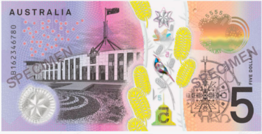
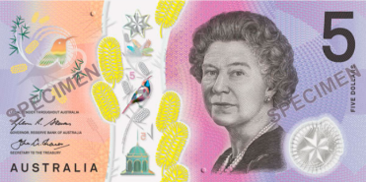
 | The design of the $5 banknote denotes the development of Australia's government and its Westminster parliamentary democracy. The act of Federation brought together the country's six self-governing colonies into political union with federal structure.
Back | 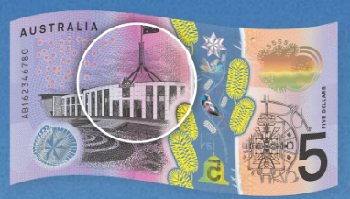 | Cultural Feature  New Parliament House, Canberra  This depiction of the New Parliament House is the designer's interpretation of various photographs. The New Parliament House was opened in 1988 by Queen Elizabeth II.  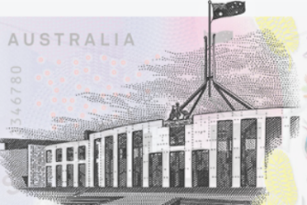
Front | 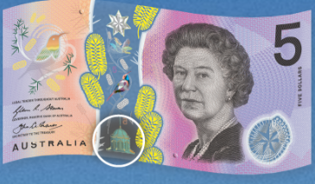  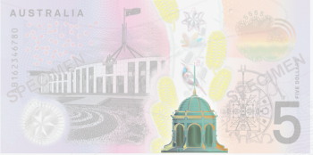 | 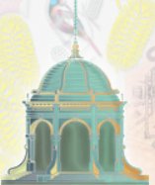  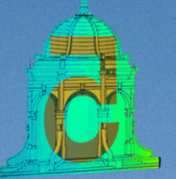 | Cultural features  Federation Pavilion  Federation Pavilion was the site of the official ceremony that marked the proclamation of the Commonwealth of Australia. The image is the designer's interpretation of various architectural photographs.  Security Feature  Reversing number: Federation Pavilion  The number of the banknote's denomination changes direction within an image of a building. The number alternately appears forwards, disappears, then reappears backwards.  The images of the building comprise: the Federation Pavilion, Sydney, New South Wales
Back |  | 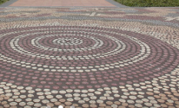  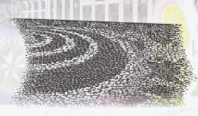 | Kumantje Jagamara AM (Luritja/Warlpiri peoples, Australia). Possum and Wallaby  Dreaming, 1985. © Estate of the artist licensed by Aboriginal Artists Agency - Parliament House Art Collection  Opened in 1988, the building includes a forecourt mosaic based on the 1985 painting, Possum and Wallaby Dreaming, by Michael Nelson Jagamara (Luritja; Warlpiri), symbolising the spiritual connection between Aboriginal and Torres Strait Islander peoples and their ancestral land.
Back | 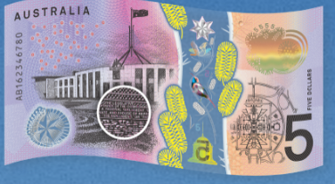 | 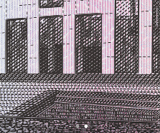 | Cultural feature  The Australian Constitution  The Australian Constitution became law on 9 July 1900 and in 1901 the six self-governing colonies of Australia were unified into a single nation, the Federal Commonwealth of Australia. The Constitution has been described as ‘the blueprint of the Commonwealth, setting out … the guidelines for the way Australians would shape their nation’
Front | 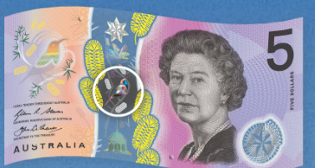 | 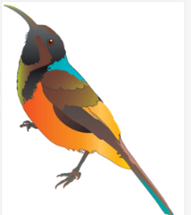 | Cultural feature  The Eastern Spinebill (Acanthorhynchus tenuirostris)  Appears on the $5 banknote; it is native to areas of South Australia, Victoria, Tasmania, New South Wales and Queensland. John Gould’s The Birds of Australia (1840–1848) notes its ‘extremely delicate bill … peculiarly suited for the extraction of insects and honey from the inmost recesses of the tubular flowers.’
Front | 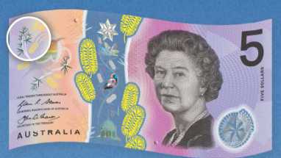 | 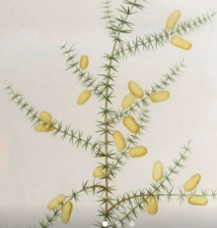 | Cultural feature  Prickly Moses wattle (Acacia ticillata subspecies ovoidea)  Appears on the $5 banknote; it grows in areas of South Australia, Victoria, Tasmania and New South Wales. Wattle has been used by First Nations peoples as a source of food and medicine for thousands of years.
Front | 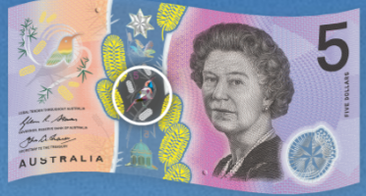 | 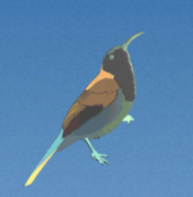 | Design and security features  Colourful Eastern Spinebill  Located in the top-to-bottom clear window, the Colourful Eastern Spinebill uses light refraction to show a spectrum of luminescent colours. This effect is created through the application of a separate strip of features to the banknote’s clear window. To see this appear on your own banknote tilt the banknote from side to side under a light source.
 | 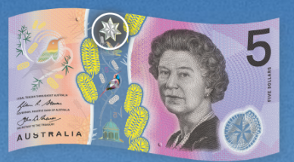 | 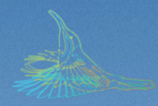 | Design and security features  Flying Eastern Spinebill  Located in the top-to-bottom clear window, the Flying Eastern Spinebill uses light refraction to appear in flight. This effect is created through the application of a separate strip of features to the banknote’s clear window. To see this appear on your own banknote tilt the banknote from side to side under a light source.
Front | 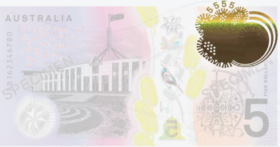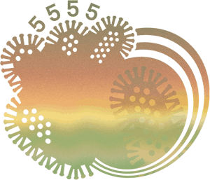 | 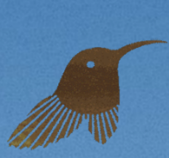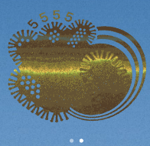 | Design and security features  Rolling colour effect  The effect appears in a prominent patch near the top corner on one side of the banknote, and within a bird shape on the banknote's other sideSeen on both sides of your banknote, a shimmering patch in the shape of an oval or bird will produce a rolling effect and colour change when tilted. This effect is created by applying magnets to metallic ink in the printing process – changing the direction of the ink pigments. To see
Front | 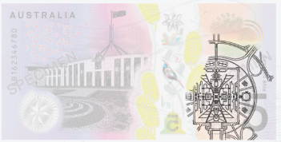 | 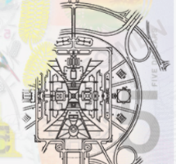 | Design features  Floor Plan  This visual element is based on the aerial view of Parliament House building, including the House of Representatives, Senate and sporting facilities.
 | 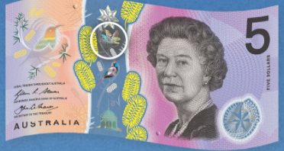 | 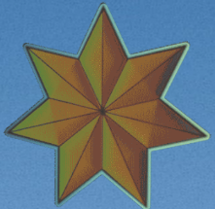 | Design and security features  3D Federation Star  Located in the top-to-bottom clear window, the 3D Federation Star uses light refraction to appear three-dimensional. This effect is created through the application of a separate strip of features to the banknote’s clear window. To see this appear on your own banknote tilt the banknote from side to side under a light source.
Front | 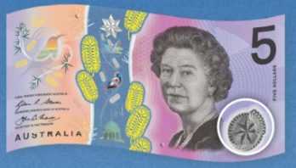 |    | Design and security features  Federation Star  Integrated with the banknote is a small window. It includes an image that is embossed and has a light and dark effect. The images for this feature comprise: the Federation star ($5)  3D Federation Star  Located in the bottom corner of your banknote you will find the Federation Star, an embossed symbol that you can feel. Tilting your banknote from side to side you will also see areas in the star flip between light and dark, when under a light source.
Front |   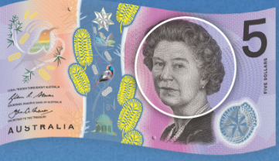 | Design and security features  Her Majesty Queen Elizabeth II  Intaglio Print  The portrait of Her Majesty Queen Elizabeth II reflects the role of the monarch within the system of constitutional monarchy. The Queen first appeared on an Australian banknote in 1953 when she was portrayed on the £1 banknote. A new portrait was commissioned for the $1 banknote, first issued in 1966, and a third portrait was drawn for the $5 banknote of 1992, based on a photograph by John Lawrence from 1984. The same photograph is used as the source for the Queen's portrait on the new $5 banknote; however, more detail is apparent in this portrait owing to advances in printing technology.
Front | 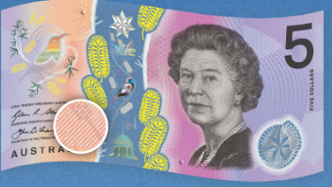 | 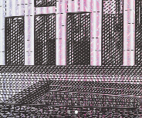  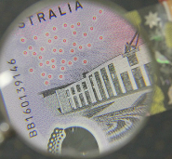 | Design and security features  Microprint  Not all of the text on Australian banknotes can be read easily. In multiple locations on your banknote you will find microprinting – tiny, clearly defined text. With the use of a magnifying glass you will find excerpts from the Australian Constitution and the value of the banknote in different locations.
Front | 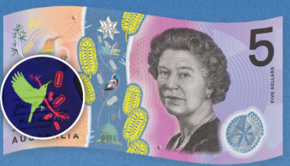 | 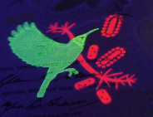 | Design and security features  Fluorescent Ink  - Not all of the ink printing on Australian banknotes can be seen with the human eye. When placed under an ultraviolet light your banknote will reveal areas of fluorescent ink – an Eastern Spinebill with wattle, the year of print and the serial number.  Fluorescent ink printing of the Eastern Spinebill and wattle are revealed on the $5 banknote under UV light
Front | 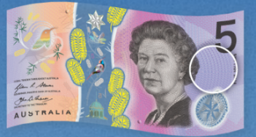 | 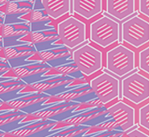 | Design and security features  Background Print  Complex multi-colour and multi-directional fine-line patterns make up the background of Australian banknotes. To create this effect, inks are layered together, and the inks are applied to both the front and back of the banknote at the same time. Their resolution is sharp and free of irregularities such as less clearly defined patterns, thicker or thinner lines, or colour differences.
 | 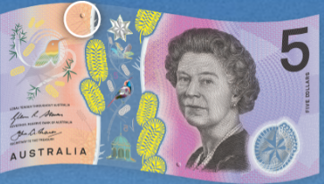 | 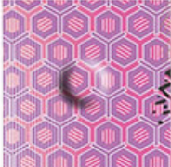 | Design and security features  Tactile Feature  To assist people with vision impairment, Australian banknotes have a bump or series of bumps located at the top and bottom of the banknote. This tactile feature lets you know the value of your banknote - one bump indicating that the banknote is worth $5. The value of Australian banknotes can also be identified by the distinctive colour and length of the banknote.
 | 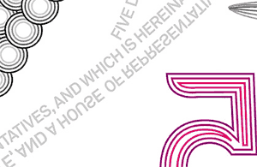  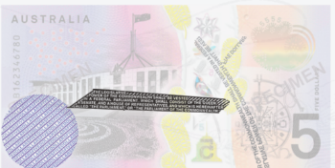  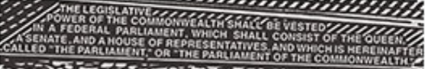 |  | Security Feature  Microprint Australian Constitution  Look for tiny, clearly defined text in multiple locations on the banknote.  Microprint - Australian Constitution  Tiny, clearly defined text can be found in multiple locations on the banknotes. A quotation from the Australian Constitution appears in microprint on the $5 banknotes
 | 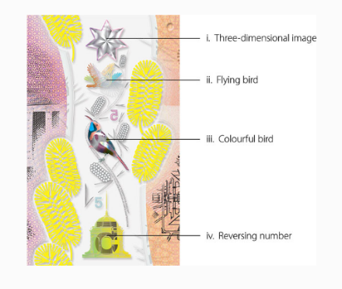 |  | Top-to-bottom clear window:  The window is integrated with the banknote, rather than being an addition. It contains a number of dynamic security features, comprising:  - Three-dimensional image  - Flying bird  - Colourful bird and  - Reversing number.
 | 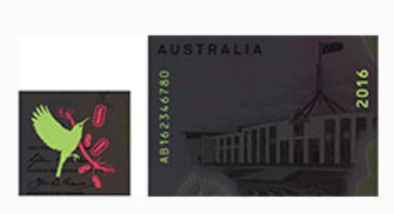 |  | Fluorescent ink - A bird, the banknote's serial number and the year of printing fluoresce under ultraviolet light.

$10
- Date of First Issue - 1 November 1993
- Size - 65mm by 137mm
- Designer - Max Robinson

Front Back
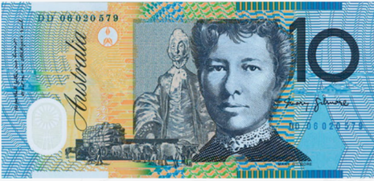
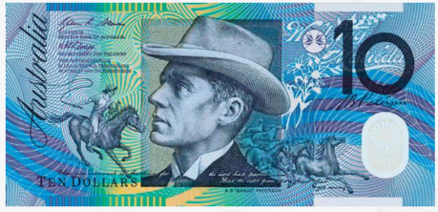
Front | 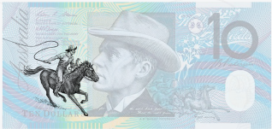 | 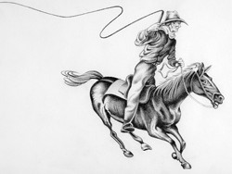 | Design Feature  Horseman  This image is the banknote designer's interpretation of an authentic horseman from the times of The Man From Snowy River.
Front | 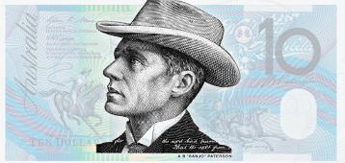 |  | Design Feature  Portrait of AB ‘Banjo’ Paterson  This portrait of AB ‘Banjo’ Paterson is based on a photograph taken at the time of his return from the Boer War in 1900.
Front | 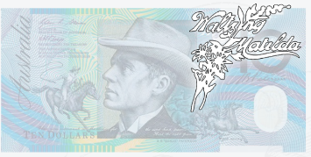 | 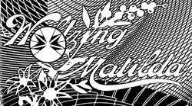 | Design Feature  Waltzing Matilda logo  This design element is taken from the 1903 publication of Marie Cowan's arrangement of Waltzing Matilda, which was used at the time to promote Billy Tea.
Front | 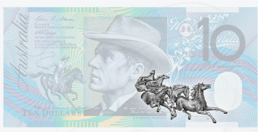 | 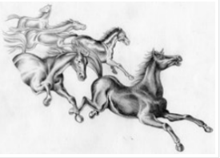 | Design Feature  Running horses (brumbies)  Inspired by the poem The Man From Snowy River, these images of horses are based on pictures that appeared in The Australian Newspaper in 1870 and The Illustrated Sydney News in 1875.
Front | 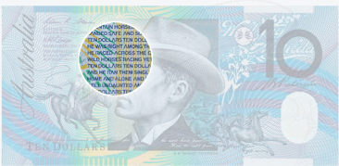 | 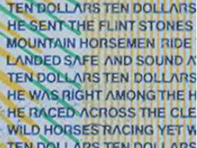 | Security feature  Microprinting  On the $10 banknote, microprinted lines from AB ‘Banjo’ Paterson's poem The Man From Snowy River are located near his portrait. On the other side, excerpts from the poem No Foe Shall Gather Our Harvest are microprinted near the image of Dame Mary Gilmore.
Front | 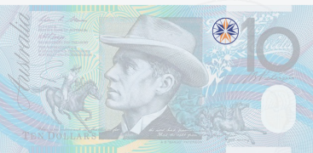 |  | Security Feature  See-through registration device  When the banknote is held up to the light, a seven-pointed star within a circle is formed by four points on one side of the banknote combining perfectly with three points on the other side.
Front | 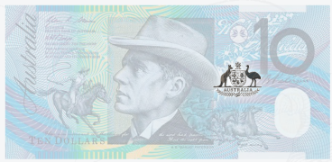 | 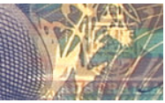 | Security feature  Shadow Image  When the banknote is held up to the light, an image of the Australian Coat of Arms can be seen faintly, under other printing.
Front | 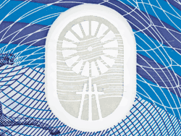  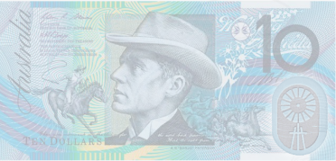 | Security Feature  Windmill  Clear window – vignette of a windmill/ On all genuine banknotes the window should be very clear and look like it's an integral part of the banknote, not an addition. Inside the clear window on the $10 banknote there is a printed image of a stylised windmill and an embossed wave pattern.
Back | 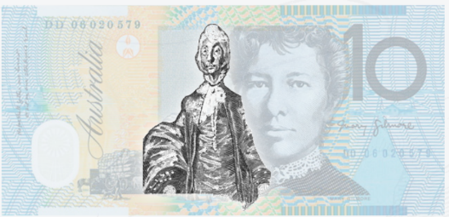 |  | Design feature  Dame Mary Gilmore  The source for this design element is a portrait of Dame Mary Gilmore by the painter Sir William Dobell. It was painted in 1957 and hangs in the Art Gallery of NSW
Back | 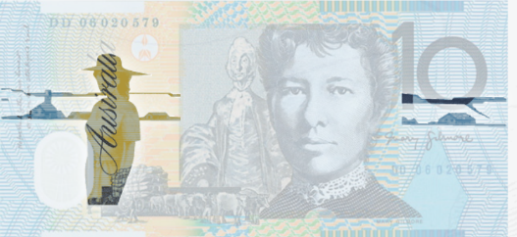 |  | Design Feature  Woman of the outback and outback scene  This imagery of a country woman and the surrounding landscape was inspired by the themes of many of Mary Gilmore's writings
Back | 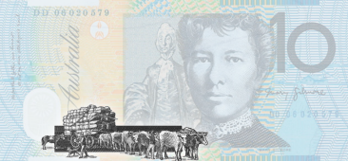 | 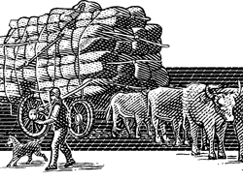 | Design feature  Bullock team carrying wool  The image of a bullock team is based on an engraving entitled ‘The Wool Season’ that appeared in The Illustrated Australian News in 1881.
Back | 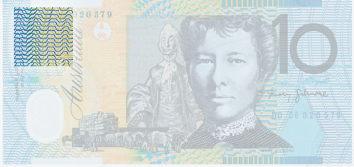 | 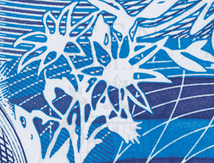 | Security feature  Backgrounds print - offset  Multi-coloured and  multi-directional patterns of fine lines appear on each side of the banknote.
Back | 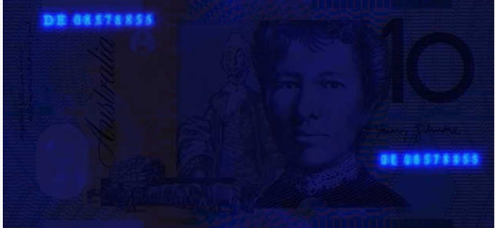 |  | Security Feature  Fluorescent ink properties  Under ultraviolet light, the serial numbers on the back of the $10 banknote glow.
Back | 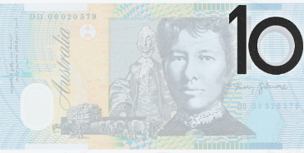 |  | Security feature  Intaglio print  Intaglio is raised dark printing with a distinct feel. It's used for the portraits on banknotes and some other design elements.

Counterfeit notes – how to detect

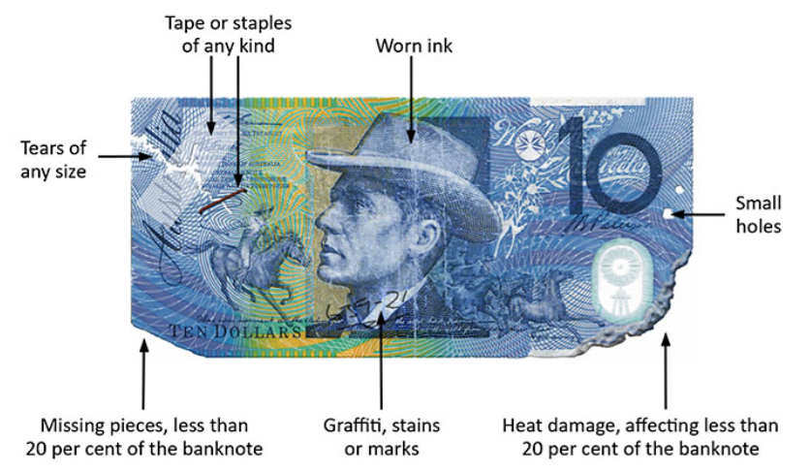

$10 - NEW

Date of First Issue - 20 September 2017

Size - 65mm by 137mm

Concept Designer - emerystudio

Front Back
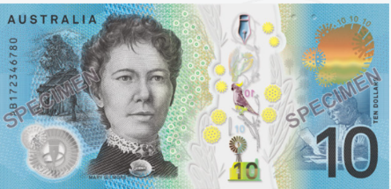
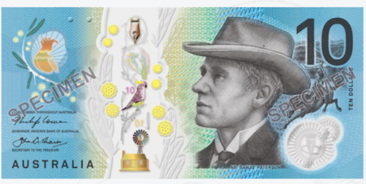
Front | Front of the $10 banknote, showing Banjo Paterson, offset and intaglio printing on polymer substrate, with a clear window depicting a windmill; concept design by Max Robinson, first issued in November 1993.
Back | Back of the $10 banknote, showing Dame Mary Gilmore, offset and intaglio printing on polymer substrate, with a clear window depicting a windmill; concept design by Max Robinson, first issued in November 1993.
Front | 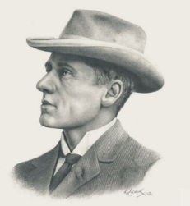  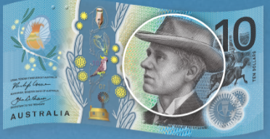 | Cultural feature  Banjo Patterson  Andrew Barton Paterson (1864–1941)  is remembered as the author of folk ballads that have acquired legendary status in Australia. Using the pseudonym ‘The Banjo’ after a family racehorse, he published verses including The Man from Snowy River (1890), that portrayed Australian bushmen, drovers and horsemen, who were characterised as independent, skilled and instinctual.  Design and security features  Intaglio Print  Using engraved printing plates, a dark ink is pressed on Australian banknotes to produce a distinctive texture. This slightly raised printing can be felt by feeling the dark areas of the banknote, such as the portrait and numerals.
Front | 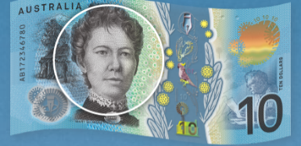 | 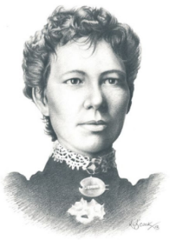 | Cultural features  Dame Mary Gilmore  (1865–1962  During the Second World War, Mary Gilmore (1865–1962) wrote some of her most celebrated verse, including No foe shall gather our harvest (1940). Concerned by the poverty she witnessed in The Rocks area of Sydney, she championed the causes of the disadvantaged in her writing. In 1895 she travelled to Paraguay to join William Lane’s socialist settlement, ‘New Australia’.
Front | 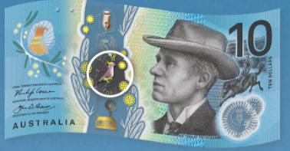 | 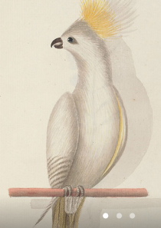 | Cultural features  Sulphur-crested Cockatoo  from John Hunter’s sketchbook, Birds and Flowers of New South Wales, c.1790 - National Library of Australia  Known for its piercing call, the Sulphur-crested Cockatoo (Cacatua galerita) inhabits most areas of Australia, as well as New Guinea and parts of Indonesia. John Gould writes in The Birds of Australia, (1840–1848), that the sound of the bird’s ‘horrid, screaming notes’ is ‘compensated for by their sprightly actions and the life their snowy forms imparted.’
Front | 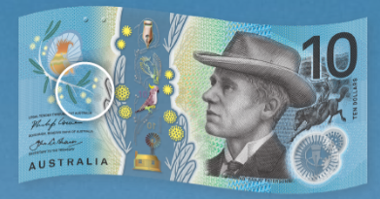 | 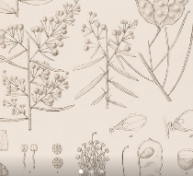  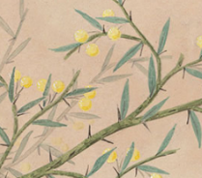 | Cultural features  Bramble Wattle  Bramble Wattle (Acacia victoriae, also known as Acacia sentis), appears on the $10 banknote. It is native to arid and semi-arid areas of Australia. Wattle has been used by First Nations peoples as a source of food and medicine for thousands of years.
Front | 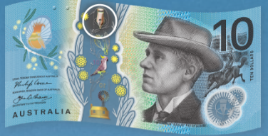 | 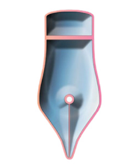  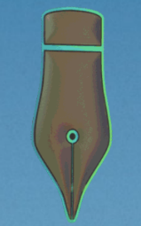 | Design and security features  3D Pen Nib  Located in the top-to-bottom clear window, the 3D Pen Nib uses light refraction to appear three-dimensional. This effect is created through the application of a separate strip of features to the banknote’s clear window. To see this appear on your own banknote tilt the banknote from side to side under a light source.  Three-dimensional image of a pen nib from the $10 banknote.
Front | 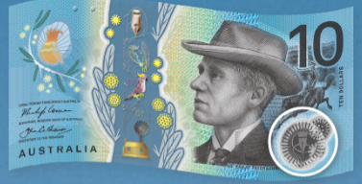 | 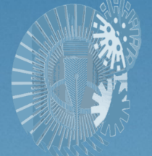 | Design and security features  Pen Nib  Located in the bottom corner of your banknote you will find the tip of a pen, an embossed symbol that you can feel. Tilting your banknote from side to side you will also see areas in the star flip between light and dark, when under a light source.
Front | 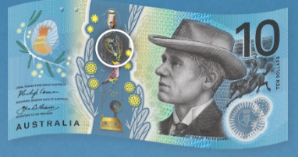 | 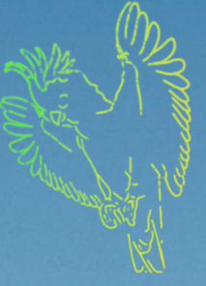 | Design and security features  Flying Cockatoo  Located in the top-to-bottom clear window, the Flying Cockatoo uses light refraction to appear in flight. This effect is created through the application of a separate strip of features to the banknote’s clear window. To see this appear on your own banknote tilt the banknote from side to side under a light source.
Front | 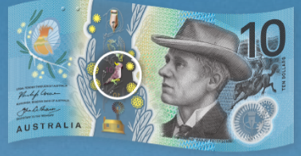 | 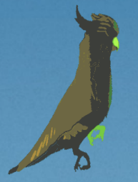 | Design and security features  Colourful Cockatoo  Located in the top-to-bottom clear window, the Colourful Cockatoo uses light refraction to show a spectrum of luminescent colours. This effect is created through the application of a separate strip of features to the banknote’s clear window. To see this appear on your own banknote tilt the banknote from side to side under a light source.
Front | 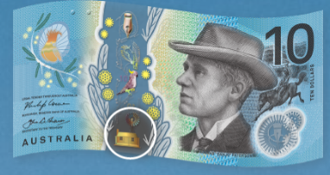 | 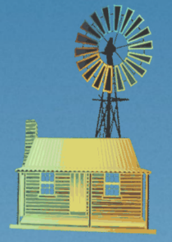 | Design and security features  Reversing 10  Located in the top-to-bottom clear window, the homestead icon uses light refraction to show the number ‘10’ and a reverse ‘10’. This effect is created through the application of a separate strip of features to the banknote’s clear window. To see this appear on your own banknote tilt the banknote from side to side under a light source.
Front | 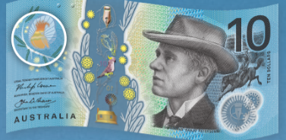 | 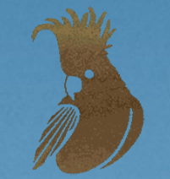 | Design and security features  Rolling Colour Effect  Seen on both sides of your banknote, a shimmering patch in the shape of an oval or bird will produce a rolling effect and colour change when tilted. This effect is created by applying magnets to metallic ink in the printing process – changing the direction of the ink pigments. To see this appear on your own banknote tilt the banknote up and down while under a light source.
Front | 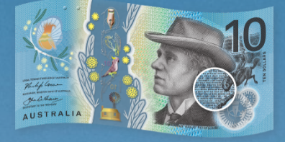 | 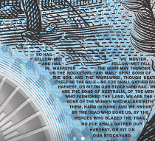 | Design and security features  Microprint  Not all of the text on Australian banknotes can be read easily. In multiple locations on your banknote, you will find microprinting – tiny, clearly defined text. With the use of a magnifying glass you will find excerpts from famous Australian poems and the value of the banknote in different locations.
Front | 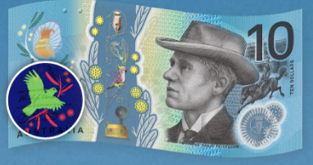 | 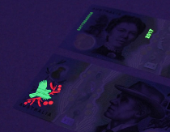 | Design and security features  Fluorescent Ink  Not all of the ink printing on Australian banknotes can be seen with the human eye. When placed under an ultraviolet light your banknote will reveal areas of fluorescent ink – a Cockatoo with wattle, the year of print and the serial number.
Front | 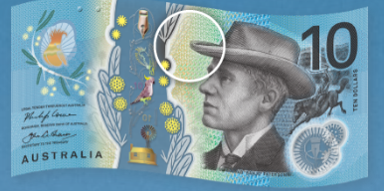 | 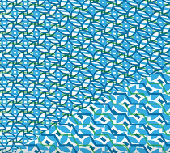 | Design and security features  Background Print  Complex multi-colour and multi-directional fine-line patterns make up the background of Australian banknotes. To create this effect, inks are layered together, and the inks are applied to both the front and back of the banknote at the same time.
Front | 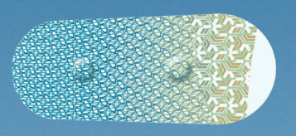  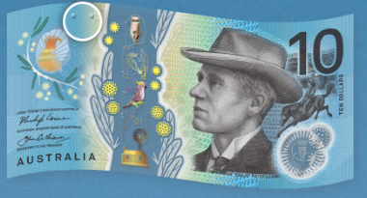 | Design and security features  Tactile Feature  To assist people with vision impairment, Australian banknotes have a bump or series of bumps located at the top and bottom of the banknote. This tactile feature lets you know the value of your banknote - two bumps indicating that the banknote is worth $10. The value of Australian banknotes can also be identified by the distinctive colour and length of the banknote.
Back | 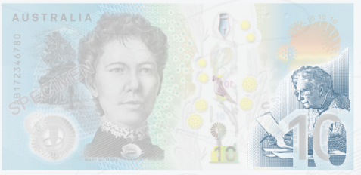 | Design Feature  Portrait of Dame Mary Gilmore at her desk  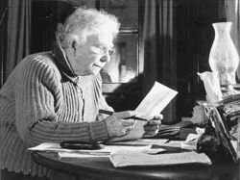  This image is based on a 1952 photograph sourced from the Herald and Weekly Times Limited portrait collection, Pictures Collection, State Library of Victoria.
Back | 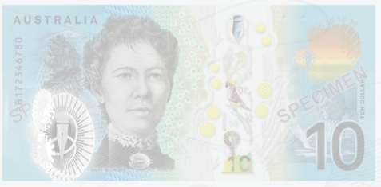 | Security Feature  Pen Nib    Look for a pen nib in a small clear window.
Back | 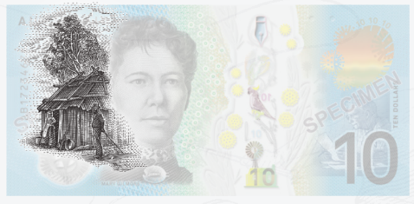 | Design Feature  Hut  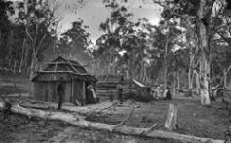  This image references life in the Australian bushland as described in Gilmore's poetry. The image is based on a photograph from the 1800s.
Back | 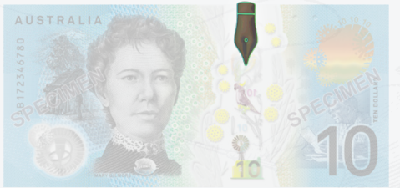 | Security Feature  3D Pen Nib  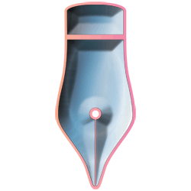  Tilt the banknote to see a three-dimensional pen nib with a colourful border.
Back | 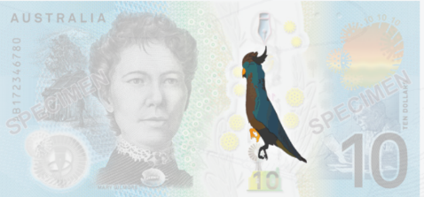 | Security Feature  Colourful Cockatoo  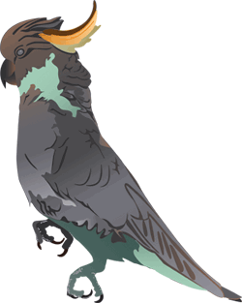  Tilt the banknote to see colours change within the Cockatoo's crest.
Back | 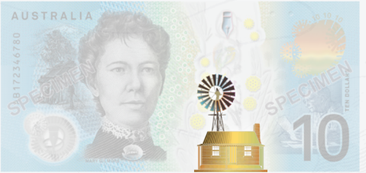 | Design Feature  Homestead  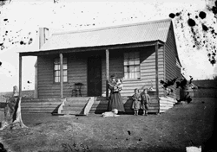  This building is representative of the type of homestead referenced in Gilmore and Paterson's works.
Back | 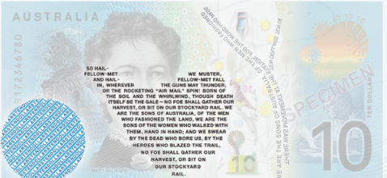 | Security Feature  Microprint  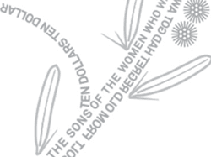  Look for tiny, clearly defined text in multiple locations on the banknote. This includes excerpts from the No Foe Shall Gather Our Harvest. ‘TEN DOLLARS’ is also microprinted in the coloured background.

